**Classroom Activity​: Check if  switch case is executed,  if the condition is true then it breaks out and the next case is not checked.​**

**Code-**

**Output-**

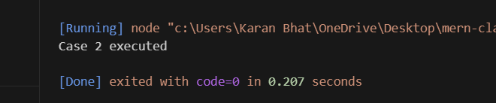

**Execution-Steps:**

* Create a JavaScript file with any name
* Write the code
* Run the code in the terminal using F5 or right click and go to inspect and you can get the output in the console as well.